**EVIDENCE OF RELEVANT SOCIAL MEDIA ACCOUNTS**

1. **FACEBOOK ACCOUNT.**

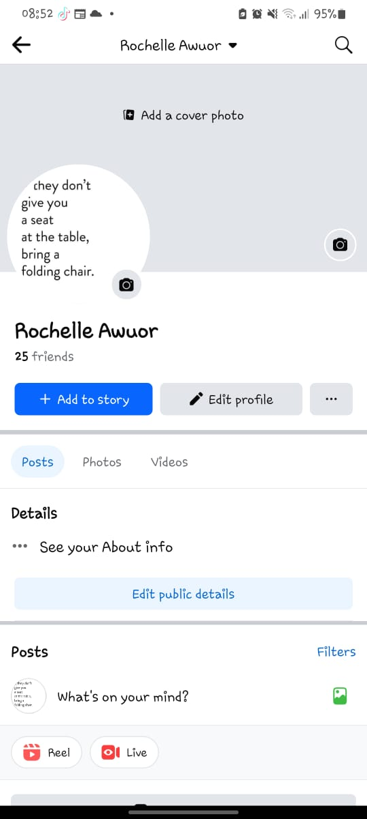

1. **TWITTER ACCOUNT**

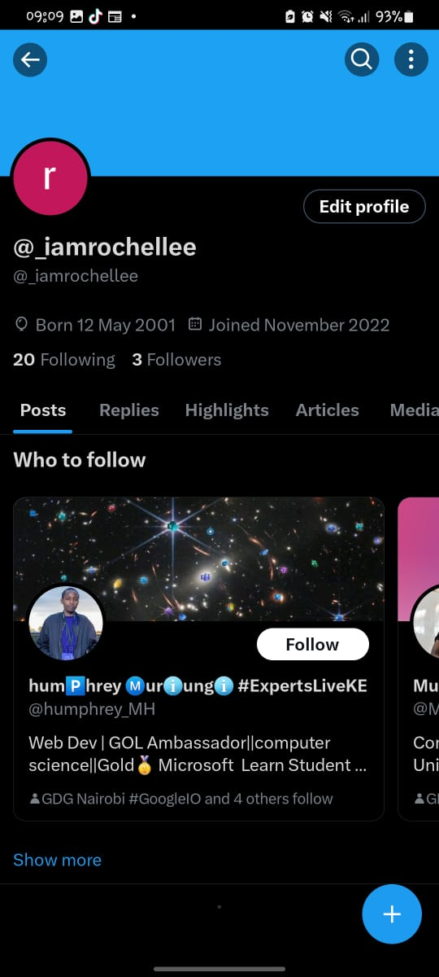

1. **INSTAGRAM ACCOUNT**

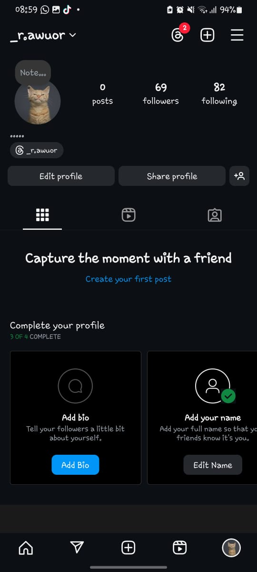

1. **WHATSAPP ACCOUNT**

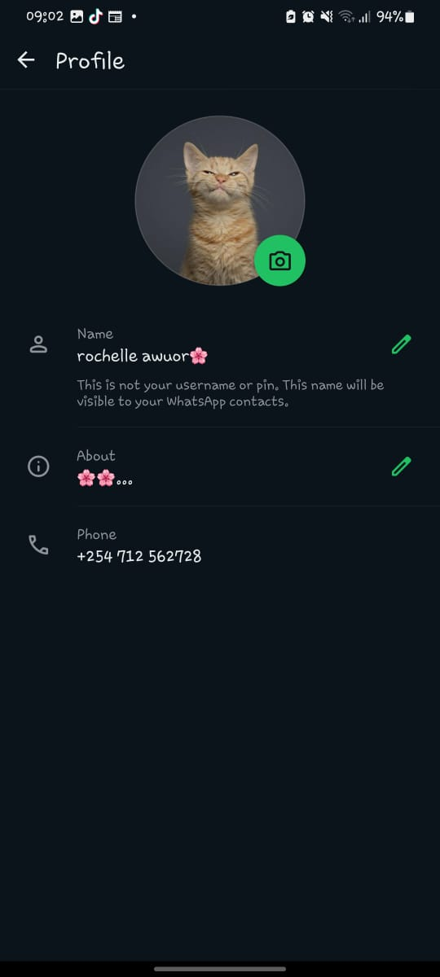

1. **LINKEDIN ACCOUNT**

